 | 12.1.22 Editors - Geometry Nodes Editor - Header - Add Menu - Instances
Table of content
Detailed table of content 1
Add menu - Instances 3
Instance on Points 3
Instances to Points 4
Realize Instances 4
Rotate Instances 5
Scale Instances 6
Translate Instances 6
Set Instance Transform 7
Instance Transform 7
Instance Rotation 8
Instance Scale 8

Detailed table of content
Detailed table of content
Detailed table of content 1
Add menu - Instances 3
Instance on Points 3
Inputs 3
Points 3
Selection 3
Instance 3
Pick Instance 3
Instance Index 3
Rotation 3
Scale 3
Output 4
Instances 4
Instances to Points 4
Inputs 4
Instances 4
Selection 4
Position 4
Radius 4
Output 4
Instances 4
Realize Instances 4
Inputs 4
Geometry 4
Outputs 5
Geometry 5
Rotate Instances 5
Inputs 5
Geometry 5
Selection 5
Rotation 5
Pivot Point 5
Local Space 5
Output 5
Geometry 5
Scale Instances 6
Inputs 6
Geometry 6
Selection 6
Scale 6
Center 6
Local Space 6
Output 6
Geometry 6
Translate Instances 6
Inputs 6
Geometry 6
Selection 6
Translation 6
Local Space 6
Output 7
Geometry 7
Set Instance Transform 7
Inputs 7
Instances 7
Selection 7
Transform 7
Output 7
Instances 7
Instance Transform 7
Output 7
Transfrom 7
Instance Rotation 8
Output 8
Rotation 8
Instance Scale 8
Output 8
Scale 8

Add menu - Instances

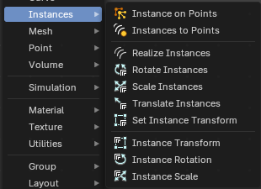

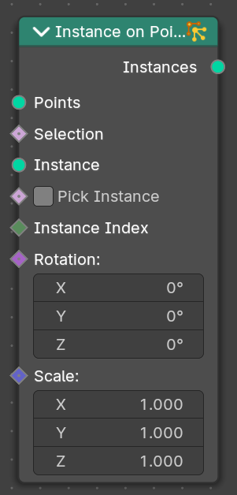
Instance on Points
Instances geometry on points.

Inputs

Points
Standard points input.

Selection
A selection of the point cloud.

Instance
Instance input.

Pick Instance
Select an instance of the point cloud.

Instance Index
The instance of the index

Rotation
The initial rotation. This is a rotation socket.

Scale
The initial scale.

Output

Instances
Instances output.

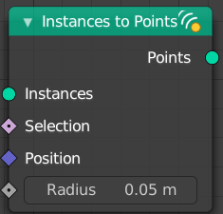
Instances to Points
This node takes a geometry set with instances as input, and outputs
points located on the origins of the top level of instances in the
geometry set (not nested instances). It also has position and radius
inputs to allow overriding the default, and a selection input to only
generate points for some instances.

Inputs

Instances
Instances input.

Selection
A selection of the instance.

Position
The position of the instance.

Radius
The radius of the points.

Output

Instances
Points output.

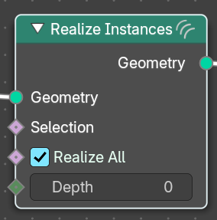
Realize Instances
Makes the instances in the geometry input real. This means each instance becomes its own object with unique mesh data. This node is useful to realize instances either on everything or to a level of instance depth.

Inputs

Geometry
Geometry Input.

Selection
Geometry Input.

Realize All
Boolean Input. This realizes all level of nested instances for a top-level realization of instances. This overrides the value of the Depth input.
Depth Input
Number of levels of nested instances to realize for each top-level instance.
Note: Only relevant when Realize All is toggled off.

Outputs

Geometry
Geometry outputs.

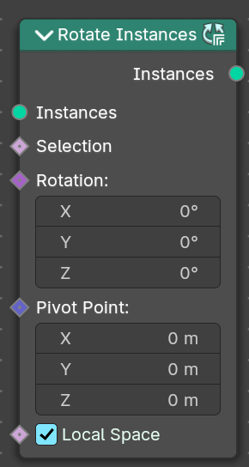
Rotate Instances
Rotates the instances of a geometry.

Inputs

Geometry
Standard geometry input.

Selection
A selection of the geometry.

Rotation
The initial rotation.

Pivot Point
The pivot point position to rotate around.

Local Space
Rotate in world space or in Local Space of the object.

Output

Geometry
Standard geometry output.

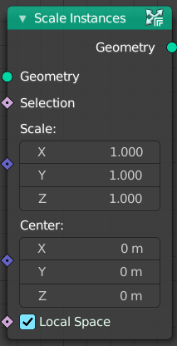
Scale Instances
Rotates the instances of a geometry.

Inputs

Geometry
Standard geometry input.

Selection
A selection of the geometry.

Scale
The initial scale.

Center
The pivot point position to scale around.

Local Space
Rotate in world space or in Local Space of the object.

Output

Geometry
Standard geometry output.

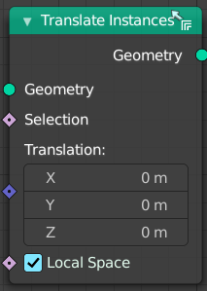
Translate Instances
Rotates the instances of a geometry.

Inputs

Geometry
Standard geometry input.

Selection
A selection of the geometry.

Translation
The amount to move.

Local Space
Rotate in world space or in Local Space of the object.

Output

Geometry
Standard geometry output.

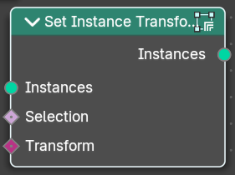
Set Instance Transform
This node allows replacing the transformation of every instance by providing a matrix.

Inputs

Instances
The input instances.

Selection
A selection of the geometry.

Transform
The transform matrix that you want to apply to every instance.

Output

Instances
The output instances.

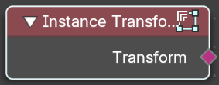
Instance Transform
Retrieves the transform of the instances.

Output

Transfrom
Transform Field output.

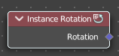
Instance Rotation
Retrieves the rotation of the instances.

Output

Rotation
Vector Field output

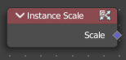
Instance Scale
Retrieves the scale of an instances.

Output

Scale
Vector Field output

